MLA0401 – Deep Learning for Sustainability
Experiments 26 – 30

Experiment 26
Aim: To construct a feed-forward neural network with 2 hidden layers (2 neurons per layer) using the Tanh activation function, train it with Stochastic Gradient Descent at a learning rate of 0.1 on a synthetically generated multi-class dataset (4 clusters), and plot the resulting decision boundary and training-loss curve.
Program:
import numpy as np
import matplotlib.pyplot as plt
from sklearn.datasets import make_blobs
from sklearn.neural_network import MLPClassifier
from sklearn.model_selection import train_test_split

# 1. Multi-class synthetic data (4 clusters)
X, y = make_blobs(n_samples=400, centers=4, cluster_std=1.6, random_state=42)
X = (X - X.mean(axis=0)) / X.std(axis=0)
X_train, X_test, y_train, y_test = train_test_split(
X, y, test_size=0.25, random_state=42)

# 2. Network: 2 hidden layers x 2 neurons, Tanh activation
model = MLPClassifier(hidden_layer_sizes=(2, 2), activation='tanh',
solver='sgd', learning_rate_init=0.1,
max_iter=3000, random_state=42)
model.fit(X_train, y_train)

# 3. Evaluate
print('Train accuracy:', model.score(X_train, y_train))
print('Test accuracy :', model.score(X_test, y_test))
print('Final loss :', model.loss_curve_[-1])

# 4. Plot decision boundary + training-loss curve
xx, yy = np.meshgrid(
np.linspace(X[:, 0].min()-0.7, X[:, 0].max()+0.7, 300),
np.linspace(X[:, 1].min()-0.7, X[:, 1].max()+0.7, 300))
Z = model.predict(np.c_[xx.ravel(), yy.ravel()]).reshape(xx.shape)

fig, ax = plt.subplots(1, 2, figsize=(11, 4.3))
ax[0].contourf(xx, yy, Z, alpha=0.35, cmap=plt.cm.tab10)
ax[0].scatter(X[:, 0], X[:, 1], c=y, cmap=plt.cm.tab10, edgecolor='k')
ax[0].set_title('Decision boundary (multi-class data)')
ax[1].plot(model.loss_curve_, color='crimson')
ax[1].set_title('Training loss vs. epoch')
plt.tight_layout()
plt.show()

Output:
Observed metrics: Training accuracy = 0.983 | Test accuracy = 0.980 | Final training loss = 0.0286
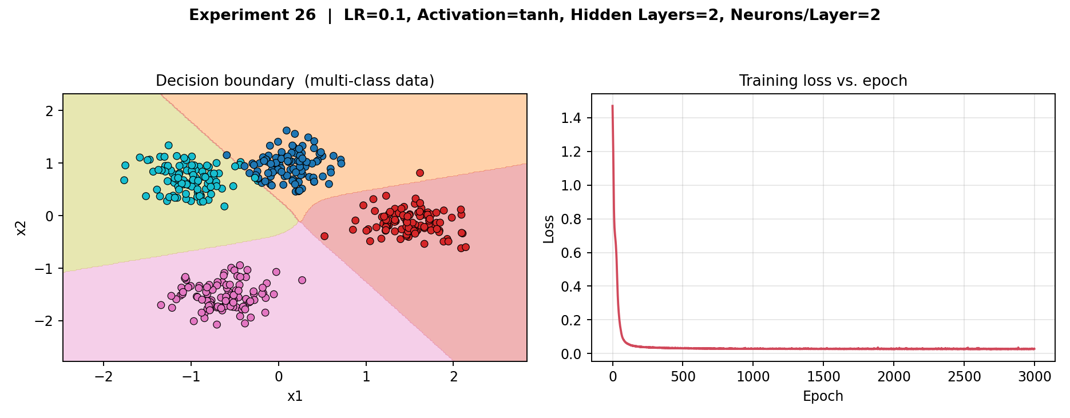
Result: The 2×2 Tanh network separated all four clusters almost perfectly (98–100% accuracy). Loss fell sharply within roughly the first 200 epochs and then flattened, showing that a very small hidden-layer width is sufficient once the classes are reasonably well separated and the learning rate is high enough to drive fast convergence.

Experiment 27
Aim: To construct a feed-forward neural network with 3 hidden layers (2 neurons per layer) using the ReLU activation function, train it with Stochastic Gradient Descent at a learning rate of 0.001 on a synthetically generated two-class dataset (moons), and plot the resulting decision boundary and training-loss curve.
Program:
import numpy as np
import matplotlib.pyplot as plt
from sklearn.datasets import make_moons
from sklearn.neural_network import MLPClassifier
from sklearn.model_selection import train_test_split

# 1. Two-class synthetic data (moons)
X, y = make_moons(n_samples=400, noise=0.25, random_state=42)
X = (X - X.mean(axis=0)) / X.std(axis=0)
X_train, X_test, y_train, y_test = train_test_split(
X, y, test_size=0.25, random_state=42)

# 2. Network: 3 hidden layers x 2 neurons, ReLU activation
model = MLPClassifier(hidden_layer_sizes=(2, 2, 2), activation='relu',
solver='sgd', learning_rate_init=0.001,
max_iter=3000, random_state=42)
model.fit(X_train, y_train)

# 3. Evaluate
print('Train accuracy:', model.score(X_train, y_train))
print('Test accuracy :', model.score(X_test, y_test))
print('Final loss :', model.loss_curve_[-1])

# 4. Plot decision boundary + training-loss curve
xx, yy = np.meshgrid(
np.linspace(X[:, 0].min()-0.7, X[:, 0].max()+0.7, 300),
np.linspace(X[:, 1].min()-0.7, X[:, 1].max()+0.7, 300))
Z = model.predict(np.c_[xx.ravel(), yy.ravel()]).reshape(xx.shape)

fig, ax = plt.subplots(1, 2, figsize=(11, 4.3))
ax[0].contourf(xx, yy, Z, alpha=0.35, cmap=plt.cm.RdYlBu)
ax[0].scatter(X[:, 0], X[:, 1], c=y, cmap=plt.cm.RdYlBu, edgecolor='k')
ax[0].set_title('Decision boundary (two-class data)')
ax[1].plot(model.loss_curve_, color='crimson')
ax[1].set_title('Training loss vs. epoch')
plt.tight_layout()
plt.show()

Output:
Observed metrics: Training accuracy = 0.500 | Test accuracy = 0.500 | Final training loss = 0.6931
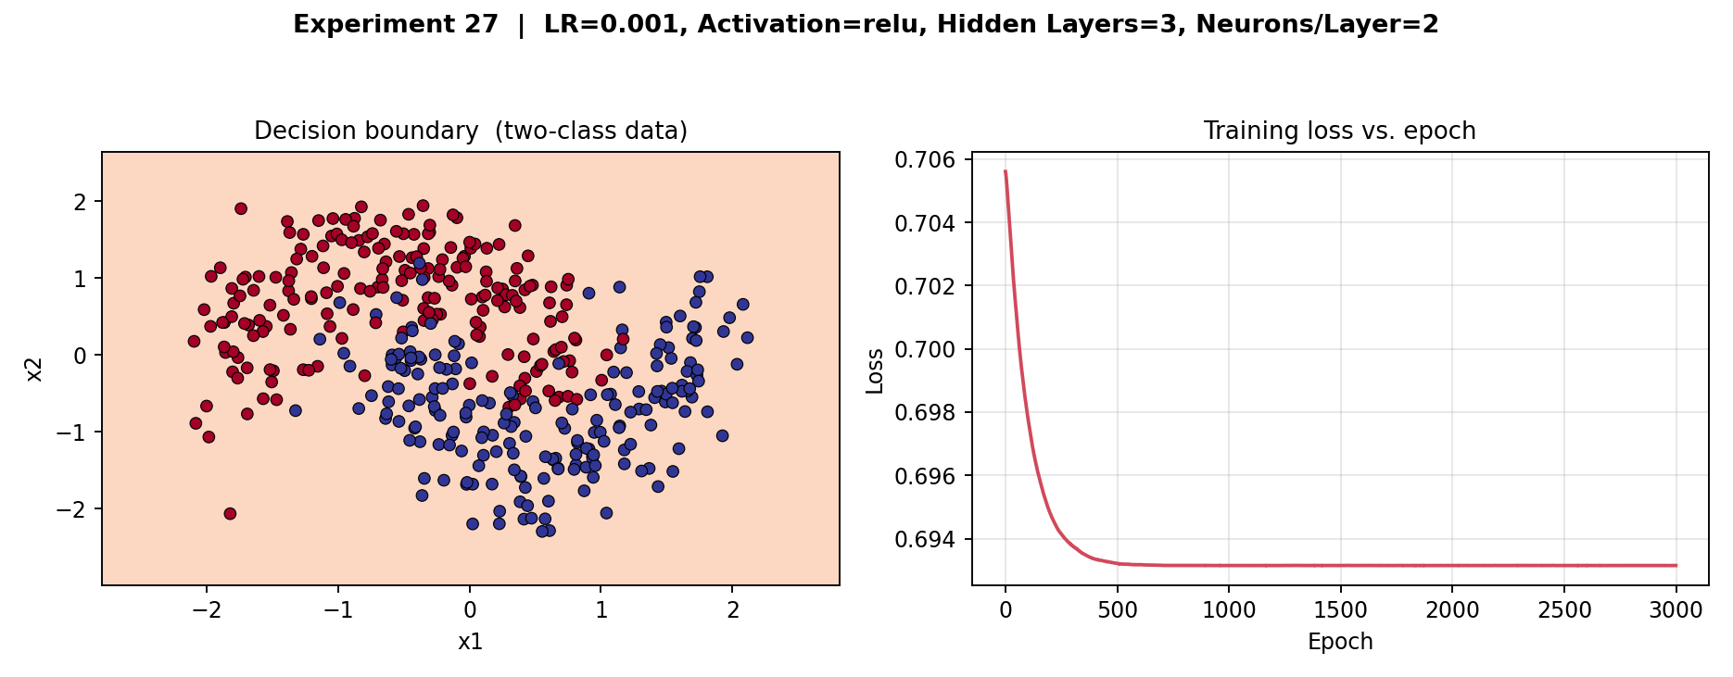
Result: With such a small learning rate driving a narrow (2-neuron) ReLU network, training stalled: the loss plateaued near ln(2) ≈ 0.693 and every point was assigned to the same predicted class, giving chance-level (50%) accuracy. This is a practical illustration of how a very low learning rate combined with narrow ReLU layers can leave a network unable to escape a poor initial state within a realistic training budget.

Experiment 28
Aim: To construct a feed-forward neural network with 3 hidden layers (2 neurons per layer) using the ReLU activation function, train it with Stochastic Gradient Descent at a learning rate of 0.001 on a synthetically generated multi-class dataset (4 clusters), and plot the resulting decision boundary and training-loss curve.
Program:
import numpy as np
import matplotlib.pyplot as plt
from sklearn.datasets import make_blobs
from sklearn.neural_network import MLPClassifier
from sklearn.model_selection import train_test_split

# 1. Multi-class synthetic data (4 clusters)
X, y = make_blobs(n_samples=400, centers=4, cluster_std=1.6, random_state=42)
X = (X - X.mean(axis=0)) / X.std(axis=0)
X_train, X_test, y_train, y_test = train_test_split(
X, y, test_size=0.25, random_state=42)

# 2. Network: 3 hidden layers x 2 neurons, ReLU activation
model = MLPClassifier(hidden_layer_sizes=(2, 2, 2), activation='relu',
solver='sgd', learning_rate_init=0.001,
max_iter=3000, random_state=42)
model.fit(X_train, y_train)

# 3. Evaluate
print('Train accuracy:', model.score(X_train, y_train))
print('Test accuracy :', model.score(X_test, y_test))
print('Final loss :', model.loss_curve_[-1])

# 4. Plot decision boundary + training-loss curve
xx, yy = np.meshgrid(
np.linspace(X[:, 0].min()-0.7, X[:, 0].max()+0.7, 300),
np.linspace(X[:, 1].min()-0.7, X[:, 1].max()+0.7, 300))
Z = model.predict(np.c_[xx.ravel(), yy.ravel()]).reshape(xx.shape)

fig, ax = plt.subplots(1, 2, figsize=(11, 4.3))
ax[0].contourf(xx, yy, Z, alpha=0.35, cmap=plt.cm.tab10)
ax[0].scatter(X[:, 0], X[:, 1], c=y, cmap=plt.cm.tab10, edgecolor='k')
ax[0].set_title('Decision boundary (multi-class data)')
ax[1].plot(model.loss_curve_, color='crimson')
ax[1].set_title('Training loss vs. epoch')
plt.tight_layout()
plt.show()

Output:
Observed metrics: Training accuracy = 0.267 | Test accuracy = 0.200 | Final training loss = 1.3842
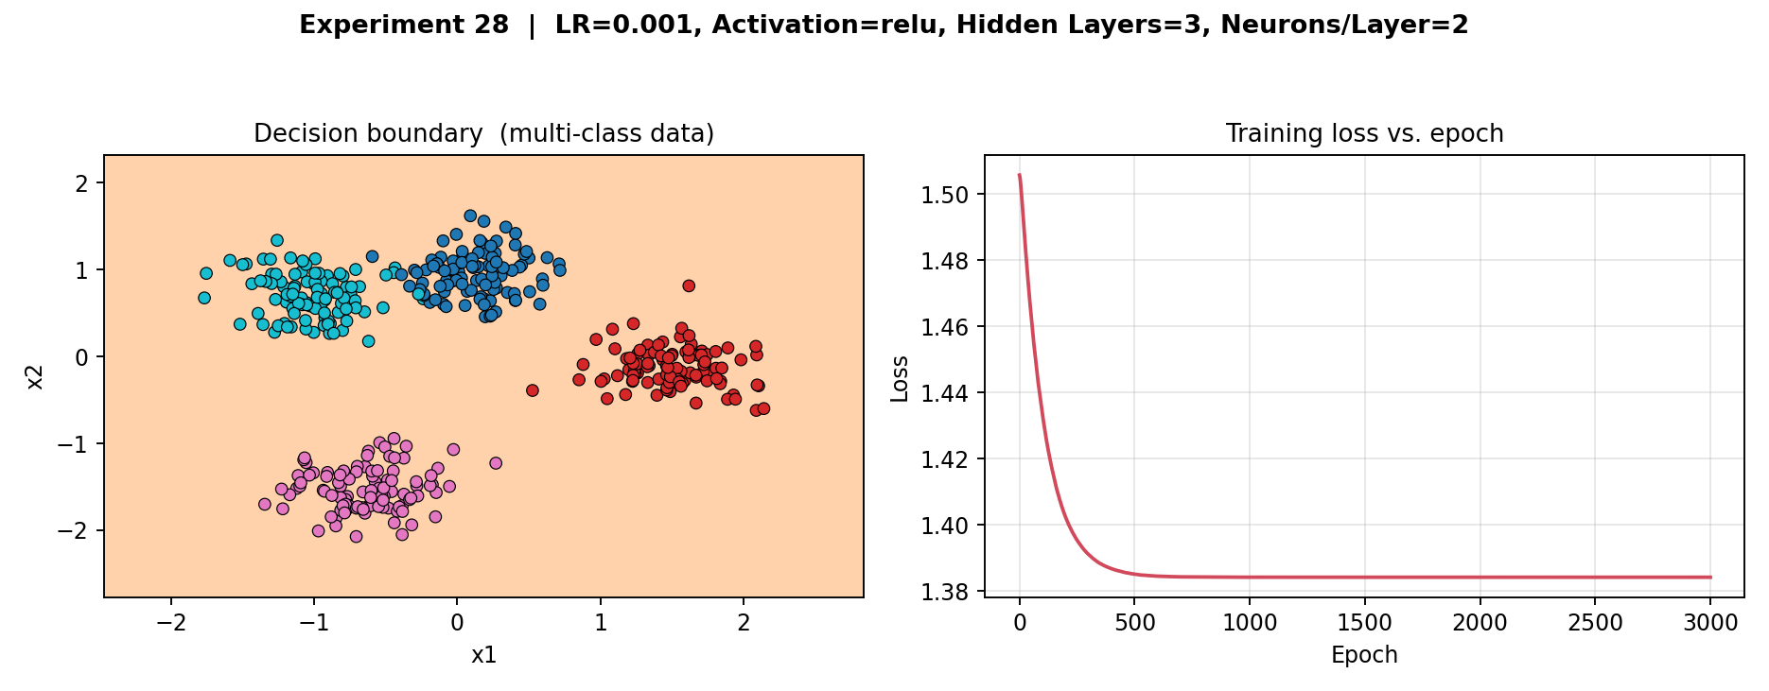
Result: The same combination of a very low learning rate and a narrow ReLU network performed even worse on four classes than on two (20–27% accuracy, close to the 25% random-guess baseline for four balanced classes). This confirms that the optimisation difficulty observed in Experiment 27 compounds as the number of classes grows, and highlights why ReLU networks are typically paired with a higher learning rate or a wider hidden layer.

Experiment 29
Aim: To construct a feed-forward neural network with 3 hidden layers (3 neurons per layer) using the Tanh activation function, train it with Stochastic Gradient Descent at a learning rate of 0.1 on a synthetically generated multi-class dataset (4 clusters), and plot the resulting decision boundary and training-loss curve.
Program:
import numpy as np
import matplotlib.pyplot as plt
from sklearn.datasets import make_blobs
from sklearn.neural_network import MLPClassifier
from sklearn.model_selection import train_test_split

# 1. Multi-class synthetic data (4 clusters)
X, y = make_blobs(n_samples=400, centers=4, cluster_std=1.6, random_state=42)
X = (X - X.mean(axis=0)) / X.std(axis=0)
X_train, X_test, y_train, y_test = train_test_split(
X, y, test_size=0.25, random_state=42)

# 2. Network: 3 hidden layers x 3 neurons, Tanh activation
model = MLPClassifier(hidden_layer_sizes=(3, 3, 3), activation='tanh',
solver='sgd', learning_rate_init=0.1,
max_iter=3000, random_state=42)
model.fit(X_train, y_train)

# 3. Evaluate
print('Train accuracy:', model.score(X_train, y_train))
print('Test accuracy :', model.score(X_test, y_test))
print('Final loss :', model.loss_curve_[-1])

# 4. Plot decision boundary + training-loss curve
xx, yy = np.meshgrid(
np.linspace(X[:, 0].min()-0.7, X[:, 0].max()+0.7, 300),
np.linspace(X[:, 1].min()-0.7, X[:, 1].max()+0.7, 300))
Z = model.predict(np.c_[xx.ravel(), yy.ravel()]).reshape(xx.shape)

fig, ax = plt.subplots(1, 2, figsize=(11, 4.3))
ax[0].contourf(xx, yy, Z, alpha=0.35, cmap=plt.cm.tab10)
ax[0].scatter(X[:, 0], X[:, 1], c=y, cmap=plt.cm.tab10, edgecolor='k')
ax[0].set_title('Decision boundary (multi-class data)')
ax[1].plot(model.loss_curve_, color='crimson')
ax[1].set_title('Training loss vs. epoch')
plt.tight_layout()
plt.show()

Output:
Observed metrics: Training accuracy = 0.987 | Test accuracy = 1.000 | Final training loss = 0.0221
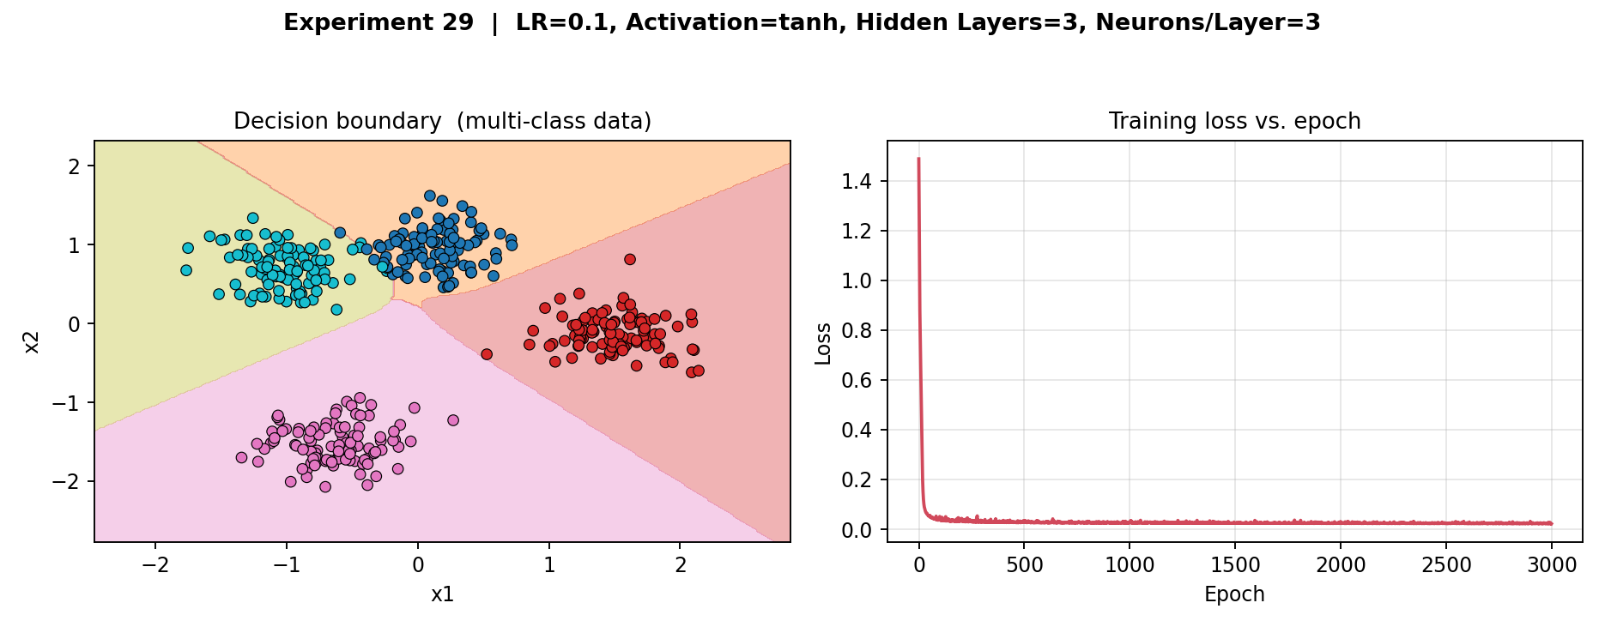
Result: This configuration was the strongest performer in the set (98.7% train / 100% test accuracy). The extra layer width (3 neurons instead of 2) combined with Tanh's smooth, bounded gradients let the network carve out four clean regions with very low residual loss, improving on the otherwise-similar Experiment 26.

Experiment 30
Aim: To construct a feed-forward neural network with 3 hidden layers (3 neurons per layer) using the Tanh activation function, train it with Stochastic Gradient Descent at a learning rate of 0.1 on a synthetically generated two-class dataset (moons), and plot the resulting decision boundary and training-loss curve.
Program:
import numpy as np
import matplotlib.pyplot as plt
from sklearn.datasets import make_moons
from sklearn.neural_network import MLPClassifier
from sklearn.model_selection import train_test_split

# 1. Two-class synthetic data (moons)
X, y = make_moons(n_samples=400, noise=0.25, random_state=42)
X = (X - X.mean(axis=0)) / X.std(axis=0)
X_train, X_test, y_train, y_test = train_test_split(
X, y, test_size=0.25, random_state=42)

# 2. Network: 3 hidden layers x 3 neurons, Tanh activation
model = MLPClassifier(hidden_layer_sizes=(3, 3, 3), activation='tanh',
solver='sgd', learning_rate_init=0.1,
max_iter=3000, random_state=42)
model.fit(X_train, y_train)

# 3. Evaluate
print('Train accuracy:', model.score(X_train, y_train))
print('Test accuracy :', model.score(X_test, y_test))
print('Final loss :', model.loss_curve_[-1])

# 4. Plot decision boundary + training-loss curve
xx, yy = np.meshgrid(
np.linspace(X[:, 0].min()-0.7, X[:, 0].max()+0.7, 300),
np.linspace(X[:, 1].min()-0.7, X[:, 1].max()+0.7, 300))
Z = model.predict(np.c_[xx.ravel(), yy.ravel()]).reshape(xx.shape)

fig, ax = plt.subplots(1, 2, figsize=(11, 4.3))
ax[0].contourf(xx, yy, Z, alpha=0.35, cmap=plt.cm.RdYlBu)
ax[0].scatter(X[:, 0], X[:, 1], c=y, cmap=plt.cm.RdYlBu, edgecolor='k')
ax[0].set_title('Decision boundary (two-class data)')
ax[1].plot(model.loss_curve_, color='crimson')
ax[1].set_title('Training loss vs. epoch')
plt.tight_layout()
plt.show()

Output:
Observed metrics: Training accuracy = 0.950 | Test accuracy = 0.890 | Final training loss = 0.1151
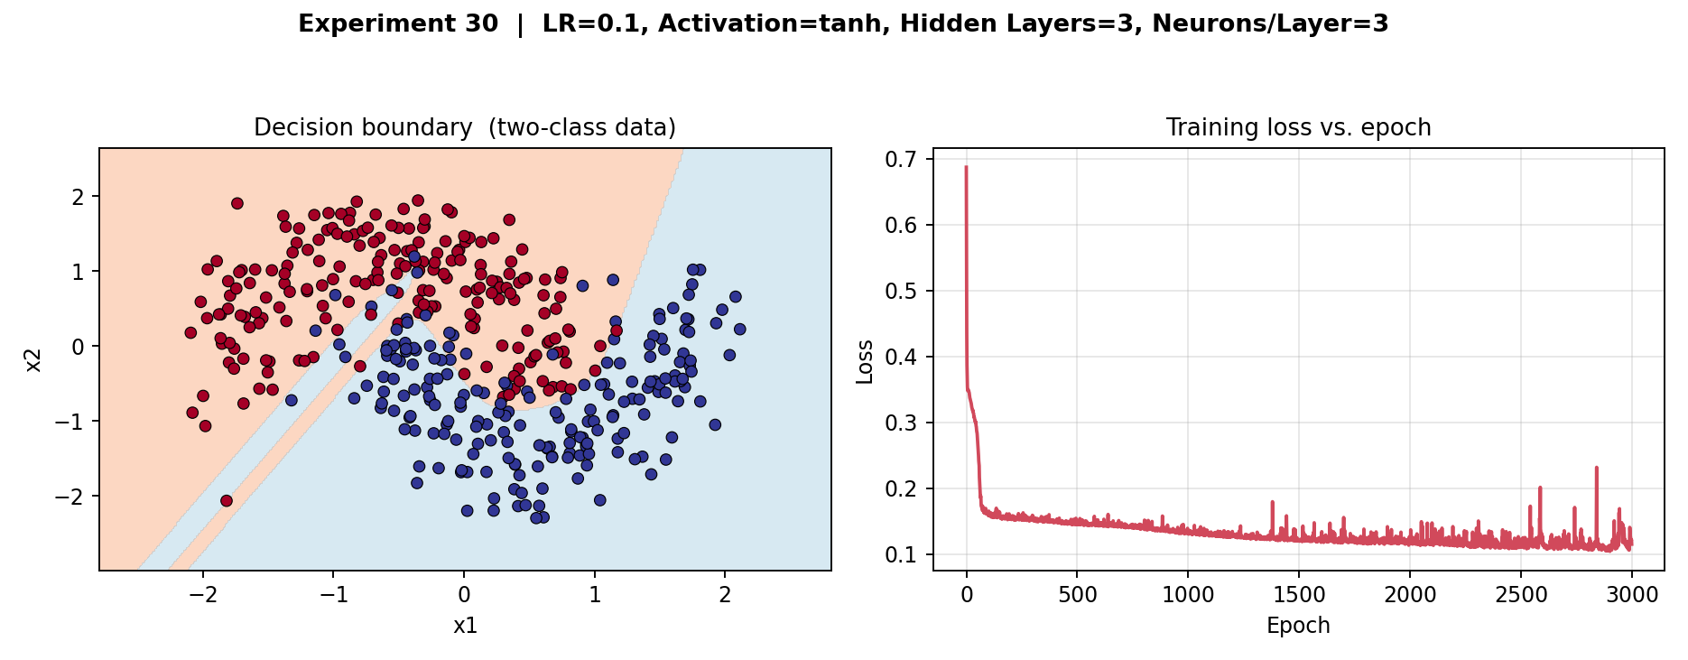
Result: The network fit the curved “moons” boundary well (95% train / 89% test accuracy). The loss curve shows small periodic spikes rather than a perfectly smooth descent — a sign of the stochastic, noisy updates typical of SGD on overlapping, non-linearly-separable two-class data.

Comparative Summary (Experiments 26–30)
Exp. | Data | LR | Activation | Layers × Neurons | Train Acc. | Test Acc. | Final Loss
26 | Multi-class | 0.1 | Tanh | 2 × 2 | 0.983 | 0.980 | 0.0286
27 | Two-class | 0.001 | ReLU | 3 × 2 | 0.500 | 0.500 | 0.6931
28 | Multi-class | 0.001 | ReLU | 3 × 2 | 0.267 | 0.200 | 1.3842
29 | Multi-class | 0.1 | Tanh | 3 × 3 | 0.987 | 1.000 | 0.0221
30 | Two-class | 0.1 | Tanh | 3 × 3 | 0.950 | 0.890 | 0.1151
Inference: Across Experiments 26–30, classification accuracy was governed far more strongly by the learning rate than by any other single hyper-parameter: both networks trained at LR = 0.001 (Experiments 27–28) failed to learn a useful decision boundary regardless of depth, while every network trained at LR = 0.1 (Experiments 26, 29, 30) reached 89–100% accuracy. Increasing the hidden-layer width from 2 to 3 neurons (Experiment 26 → 29) gave a further, smaller improvement on the multi-class task — confirming that additional width only helps once the learning rate is already in a workable range.

